**12 Reasons Why Insurance Companies Should Use A BPO**

Industries worldwide face the challenge of transforming their business processes to become more efficient, cost-effective, and customer-centric. One sector that could particularly benefit from business process outsourcing (BPO) is insurance.

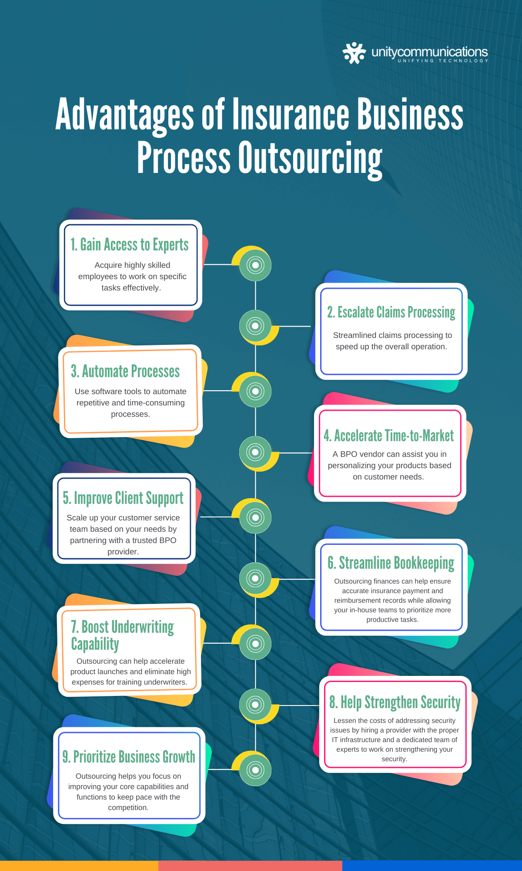

[Source](https://unity-connect.com/wp-content/uploads/2022/08/Insurance-BPO.png)

Numerous compelling reasons exist for insurance companies to leverage BPO, ranging from cost savings to access to specialized expertise.

## **1. Augmented Cost Efficiency**

A driving factor pushing insurance companies towards adopting Business Process Outsourcing (BPO) is the enticing possibility of achieving remarkable cost savings. The insurance industry is fraught with overhead expenses that, while necessary for operation, do not contribute directly to revenue generation. These costs can include those associated with maintaining infrastructure, updating and operating technology systems, and employing personnel to manage routine, non-core business tasks.

When insurance companies outsource these non-core yet essential business processes, they can substantially cut these overhead costs. In turn, the reduction in expenses that outsourcing facilitates can pave the way for the redistribution and reinvestment of these financial resources. Savings can be reallocated into core operational activities that directly impact the company's bottom line, such as developing innovative insurance policy products and enhancing customer service experiences.

Outsourcing business processes can help streamline costs and free up capital that can be strategically reinvested to drive value creation, growth, and customer satisfaction. The potential for substantial cost savings isn't merely theoretical - it's been demonstrated in practice. For instance, an in-depth report by the renowned consulting firm, [McKinsey & Company](https://www.mckinsey.com/capabilities/operations/our-insights/getting-business-process-outsourcing-right-in-a-digital-future), sheds light on the financial impact of BPO adoption. The report reveals that companies across different industries that have embraced BPO have experienced significant cost reductions, with the magnitude of savings ranging between [15% and 25%](https://www.mckinsey.com/capabilities/operations/our-insights/getting-business-process-outsourcing-right-in-a-digital-future). This significant potential for cost-efficiency underscores the value proposition that BPO can bring to the table for insurance companies.

## **2. Access to Specialized Expertise**

Business process outsourcing is a veritable gold mine of expertise and specialized knowledge for an insurance company. Often, certain skills and proficiencies are not organically present within an insurance company's internal structure, and developing them in-house may require significant investment in time and resources. This is where the vital role of BPO comes into play in the insurance industry.

Insurance BPO services fill this skills gap, providing insurance companies with ready access to a treasure trove of niche expertise that might not be readily cultivated in-house. This enables insurance companies to bolster their operations and business strategy with capabilities that might otherwise have been beyond their reach.

These specialized services provided by business process outsourcing companies cover a vast range of critical functions within the insurance business framework. Key areas that are often outsourced include actuarial services, which are integral to calculating risks and premiums; claims processing, a vital element in customer satisfaction; and fraud detection, an essential component of risk management.

With BPO, insurance companies can strengthen these areas of their operations, thereby enhancing their effectiveness and efficiency. This increased operational robustness, facilitated by outsourcing, can give insurance companies a significant competitive advantage in today's fast-paced and dynamic marketplace.

The impact of insurance business process outsourcing isn't merely theoretical. A [survey](https://www2.deloitte.com/content/dam/Deloitte/ie/Documents/Consulting/global-shared-services-2021-150621.pdf) conducted by Deloitte in 2021 brought to light compelling empirical evidence of the strategic value that BPO brings to the table. The survey findings revealed that [more than half - 57%](https://www2.deloitte.com/content/dam/Deloitte/ie/Documents/Consulting/global-shared-services-2021-150621.pdf) to be precise - of the companies that were leveraging BPO services reported gaining a competitive edge as a result. This data underscores the transformative potential that BPO holds for insurance companies, enabling them to enhance their operations, improve service delivery, and strengthen their market positioning.

## **3. Improved Focus on Core Business Functions**

The strategic utilization of BPO provides an essential avenue for insurance companies to streamline their operational focus and dedicate their resources more effectively. At the heart of BPO's value proposition is the ability to significantly shift the allocation of a company's attention and resources from routine, non-core tasks to the strategic, core functions that define their business and drive growth.

Non-core tasks often encompass a broad array of activities, ranging from the meticulous yet monotonous data entry, the diligent processing of myriad documents, and even the important yet time-consuming customer service interactions. While essential to an insurance company's day-to-day operations, these tasks do not directly contribute to strategic growth and innovation and can tie up substantial resources.

The engagement of a business process outsourcing partner can radically alter this dynamic. Outsourcing service providers specialize in taking over these non-core tasks, freeing insurance companies to channel their energy, time, and resources toward their core business functions. This strategic shift in focus allows insurance companies to focus more on key areas such as strategic planning, fostering innovation, and driving growth. This reallocation of focus is not merely beneficial - it's vital in an increasingly competitive insurance market.

But the benefits of leveraging a business process outsourcing partner go beyond just the shift in focus. BPO also offers tangible improvements in business process management. Outsourcing these routine tasks to specialized providers with the expertise and processes to handle them more efficiently can significantly improve overall productivity.

This improvement in efficiency is not merely anecdotal. A [study conducted by IBM](https://www.ibm.com/topics/business-process-outsourcing) underscores the quantifiable benefits that can be derived from outsourcing non-core tasks. The study revealed that companies that decided to outsource these tasks saw a significant uptick in their efficiency and productivity metrics - an increase of as much as [15%](https://www.ibm.com/topics/business-process-outsourcing).

In the context of insurance claims, a notoriously complex and resource-intensive area, the impact of this increased efficiency can be even more pronounced. By outsourcing the multifaceted processes involved in insurance claims handling, insurance companies can improve their claims processing efficiency and enhance customer satisfaction and loyalty.

## **4. Enhanced Customer Experience**

As we navigate through the era of elevated consumer expectations, insurance companies face a pressing mandate to enhance the quality and personalization of their services. With customers expecting more tailored, responsive, and high-quality service than ever before, the insurance sector must rise to the occasion. Here is where the role of BPO providers becomes vital.

BPO providers bring to the table deep expertise in managing customer interactions efficiently and empathetically. They also harness advanced technologies such as Artificial Intelligence (AI) and chatbots to add another layer of efficiency and personalization to customer interactions. This blend of human skills and technological capabilities can significantly empower insurance companies to elevate their customer experience.

But the positive impact of BPO providers on customer service isn't just theoretical - empirical evidence also supports this. As highlighted in a report by Accenture, companies that chose to outsource their customer service operations saw tangible improvements in customer satisfaction. The increase wasn't marginal either - [satisfaction rates surged by up to 30%](https://www.accenture.com/us-en/services/business-process-outsourcing-index). This demonstrates that leveraging the expertise of BPO providers can result in a noticeable enhancement in customer satisfaction, further justifying the strategic value of outsourcing in the insurance sector. [**4**](https://chat.openai.com/?model=gpt-4#user-content-fn-4%5E).

## **5. Scalability and Flexibility**

One of the most persuasive arguments for insurance companies to embrace BPO lies in its remarkable scalability in response to fluctuating market conditions. This flexibility is a strategic asset, especially during periods of intense demand requiring swift and efficient operational scaling. Instances of such peak periods include open enrollment phases or the aftermath of natural disasters when the volume of claims can surge dramatically.

In these scenarios, the capabilities of BPO providers shine brightly. They are adept at seamlessly scaling services up or down, aligning with the insurance company's needs at any given moment. This responsive scaling is not just about managing an increased workload. It's about maintaining, and often improving, the quality of service during these high-demand phases, ensuring that the company's customer satisfaction and reputation remain uncompromised.

Importantly, the scalability offered by BPO providers does not demand hefty investments from the insurance company in terms of recruitment, training, or infrastructure. This is a critical advantage, as these investments can be substantial, especially when the need for scaling is temporary or cyclical. The BPO providers take on the task of adjusting the scale of operations, relieving insurance companies of the associated costs and efforts.

## **6. Technological Edge**

BPO companies are at the forefront of technological advancements, offering their clients the latest digital solutions, including automation, AI, analytics, and more. These technologies can streamline and enhance insurance processes, from underwriting to claims management. An [Everest Group study shows that 80%](https://www.everestgrp.com/business-process-outsourcing-or-operations-or-management-or-services-sherpas-in-blue-shirts/) of enterprises that leveraged BPO experienced an increase in their technological capabilities.

## **7. Regulatory Compliance**

Insurance is a heavily regulated industry with complex and ever-evolving legal requirements. BPO providers specializing in the insurance sector bring a thorough understanding of these regulations and the expertise to ensure compliance. A [2022 PwC report](https://www.pwc.com/m1/en/services/consulting/risk-regulatory.html) highlights the role of outsourcing in helping companies navigate regulatory complexities

## **8. Data Management**

The ability to efficiently manage and analyze large volumes of data is critical in today's insurance industry. BPO providers have advanced data management capabilities and the expertise to turn raw data into valuable insights. These insights can inform strategic decisions and provide a competitive edge, as detailed in a report by [Boston Consulting Group](https://www.bcg.com/publications/2019/dividends-digital-marketing-maturity).

## **9. Faster Claim Processing**

One of the key drivers of customer satisfaction in the insurance industry is the speed and efficiency of claims processing. In this respect, Business Process Outsourcing (BPO) providers can be pivotal in accelerating this process. With their extensive experience in the sector and strategic use of automation technologies, BPO providers can significantly expedite claims processing times.

The faster a claim is processed, the quicker a customer can get their issues resolved or their compensation paid. This swift resolution directly enhances the customer experience and satisfaction, which, in turn, boosts the reputation of the insurance company. It's a win-win scenario for the insurance company and its customers.

BPO providers' value to the claims processing is not just theoretical. There's substantial empirical evidence to back it up. According to a study conducted by Capgemini, outsourcing claims processing to a BPO provider led to an impressive reduction in processing time. On average, the study found that companies that outsourced their claims processing saw a [reduction of 30%](https://www.capgemini.com/br-pt/wp-content/uploads/sites/8/2017/07/Claims_Transformation.pdf) in the time it took to process a claim. This statistic underscores the tangible benefits that insurance companies can derive from partnering with a BPO provider to process their claims.

## **10. Digital Transformation**

Partnering with digital-native BPO providers can significantly accelerate the digital transformation journey for insurance companies. These providers bring in state-of-the-art digital tools and proficiency, fostering a culture of innovation vital for driving digital change.

Key among the offerings of BPO providers is data processing services equipped with advanced analytics. These services can uncover crucial insights, aiding in creating finely-tuned insurance proposals. Insurance companies can streamline their processes by incorporating such sophisticated digital tools, leading to greater efficiency.

Moreover, BPO providers are a source of deep-seated digital expertise. This know-how is applied in numerous ways, such as improving customer interaction through AI-driven platforms. This enhancement improves efficiency and decreases the workload on a single customer service representative, improving service quality.

Furthermore, the innovation-driven culture these digital-native BPO providers bring can catalyze an insurance company's digital transformation, impacting every facet of its operation. This notion of innovation can reduce operational costs and invoke a considerable shift toward digitization.

An [EY report](https://www.ey.com/en_gl/consulting/how-digital-platforms-can-support-your-transformation-journey) underscores the substantial role BPO can play in an organization's digital transformation. The report signifies how BPO can drive digital change beyond just reducing costs and enhancing efficiency.

## **11. Risk Management**

BPO providers offer sophisticated risk management solutions. They bring industry-specific expertise and use state-of-the-art technologies to predict, assess, and manage risks, a key aspect in the insurance sector. According to a [Gartner report, 70%](https://www.gartner.com/smarterwithgartner/revisit-risk-in-the-age-of-digital-transformation) of the companies that outsourced risk management reported better risk control and mitigation

## **12. Market Expansion**

Insurance companies looking to expand into new markets can benefit significantly from the local knowledge of BPO providers. This can include understanding local laws, consumer behavior, and competition. As a [KPMG report suggests](https://kpmg.com/nl/en/blogs/home/posts/2022/07/managed-services-more-than-just-business-process-outsourcing-bpo.html), using BPO can ease the expansion into new markets, providing local insights and supporting compliance with local regulations

All in all, the strategic advantages of incorporating BPO into the operational framework of insurance companies are manifold. From cost efficiency and improved focus on core operations to data management and digital transformation, BPO presents a significant opportunity to enhance operational efficiency, maintain regulatory compliance, and ultimately, drive customer satisfaction. As the insurance landscape continues to evolve and competitive pressures intensify, leveraging the power of BPO can provide the necessary edge to remain ahead of the curve.